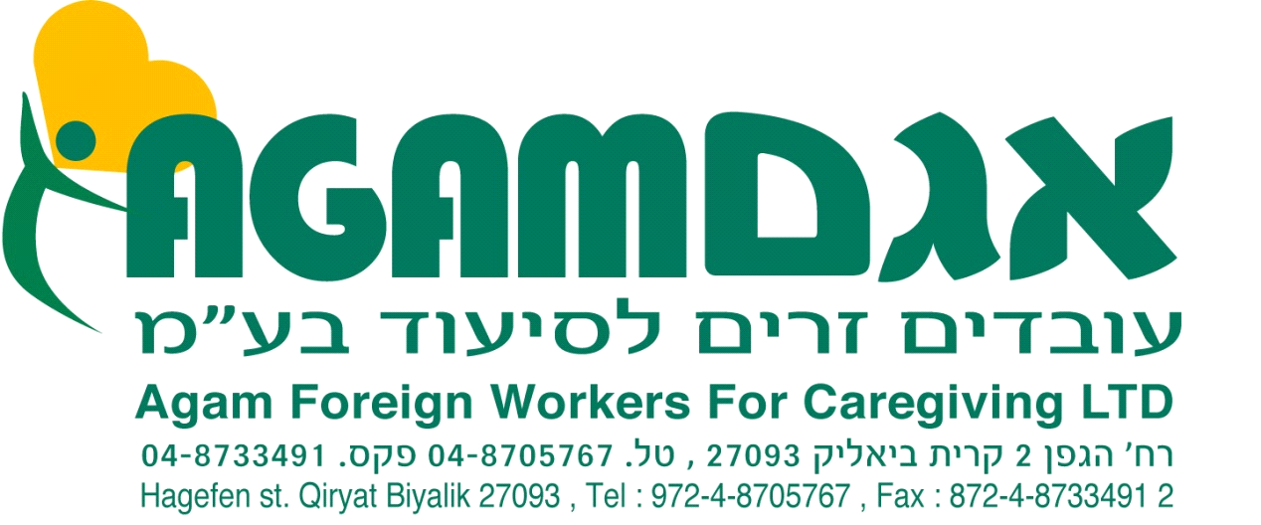
LIST OF HOLIDAYS FOR WORKERS 2021 – Georgia
חגים 2021- גאורגיה
Sign | Date | Holiday
 | 1-2/1/2021 | New year's day
 | 07/01/2021 | Orthodox Cgristmas
 | 19/01/2021 | Orthodox Epiphany
 | 03/03/2021 | Mothers Day
 | 08/03/2021 | International Women's Day
 | 09/04/2021 | Day of National Unity
 | 30/04/2021 | Orthodox Good Friday
 | 01/05/2021 | Orthodox Easter Day
 | 03/05/2021 | Orthodox Easter Monday
 | 09/05/2021 | Victory Day
 | 12/05/2021 | Saint Andrew
 | 26/05/2021 | Independence Day
 | 28/08/2021 | Saint Mary's Day
 | 14/10/2021 | Svetitskovloba
 | 23/11/2021 | Saint George
 | 25/12/2021 | Catholic Christmas

- לפי החוק כל עוב' זר זכאי ל- 9 ימי חג בשנה, כל יום חג בן 25 שעות.
- The worker can choose 9 holiday's according to his religious.
- Every exit for a holiday is for 25 hours.

HAPPY HOLIDAY'S

